PUSH BUTTON

SCHNEIDER

1. NO PUSH BUTTONS

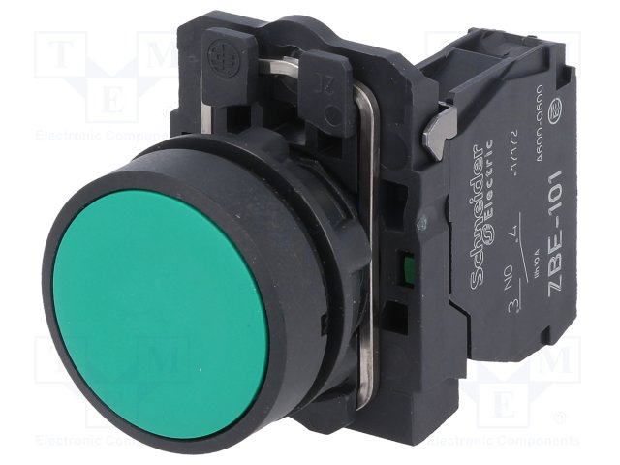

1. NC PUSH BUTTON

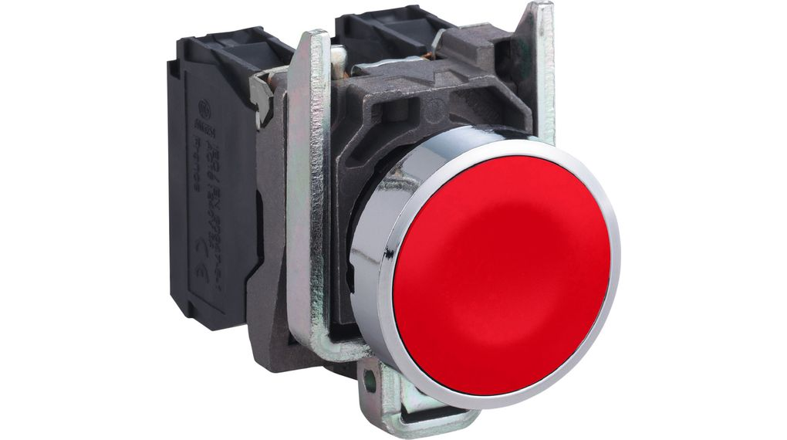

1. ILLUMINATED NC PUSH BUTTON

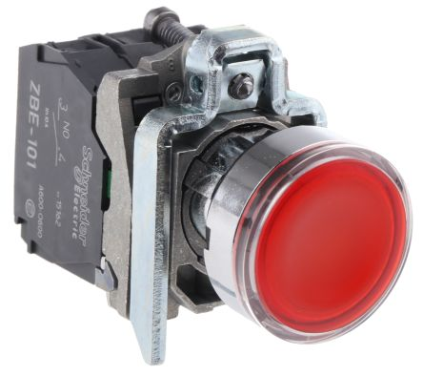

1. ILLUMINATED NO PUSH BUTTON

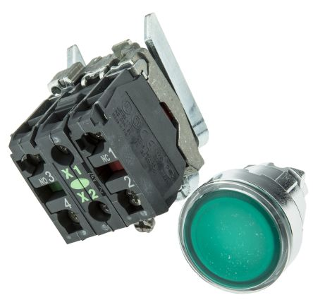

1. EMERGENCY SWITCH

